MOUNT KENYA UNIVERSITY
DEPARTMENT of INFORMATION TECHNOLOGY
COURSE CODE: BIT4107 - MOBILE APPLICATION DEVELOPMENT
PROJECT WEEKLY LOGBOOK WORKSPACE (WEEKS 1 - 3)

STUDENT DETAILS:
Name: John Njoroge Gachanja
Registration Number: BIT/2024/74648
WEEK 1: ENVIRONMENT CONFIGURATION & GIT PIPELINE SETUPS
1. OBJECTIVES:
* Setup a professional cross-platform Flutter development environment.
* Initialize local version control using Git and establish a secure cloud repository backup on GitHub.
* Compile and test an initial cross-platform "Hello World" mobile application layout.

2. ACTIVITIES COMPLETED:
* Installed Android Studio IDE, Flutter Web SDK, and configured local Git pipelines.
* Initialized Git on the local project directory under the 'master' branch.
* Created a secure cloud repository hosted via the cloud handle: https://github.com/jn4546731-ship-it/student_app

3. CHALLENGES FACED & SOLUTIONS IMPLEMENTED:
* Challenge: Git configuration initially un-tracked files when the directory was formed.
* Solution: Utilized Android Studio's Version Control Integration to explicitly stage and commit 128 foundational project configuration files.

4. EVIDENCE VERIFICATION:
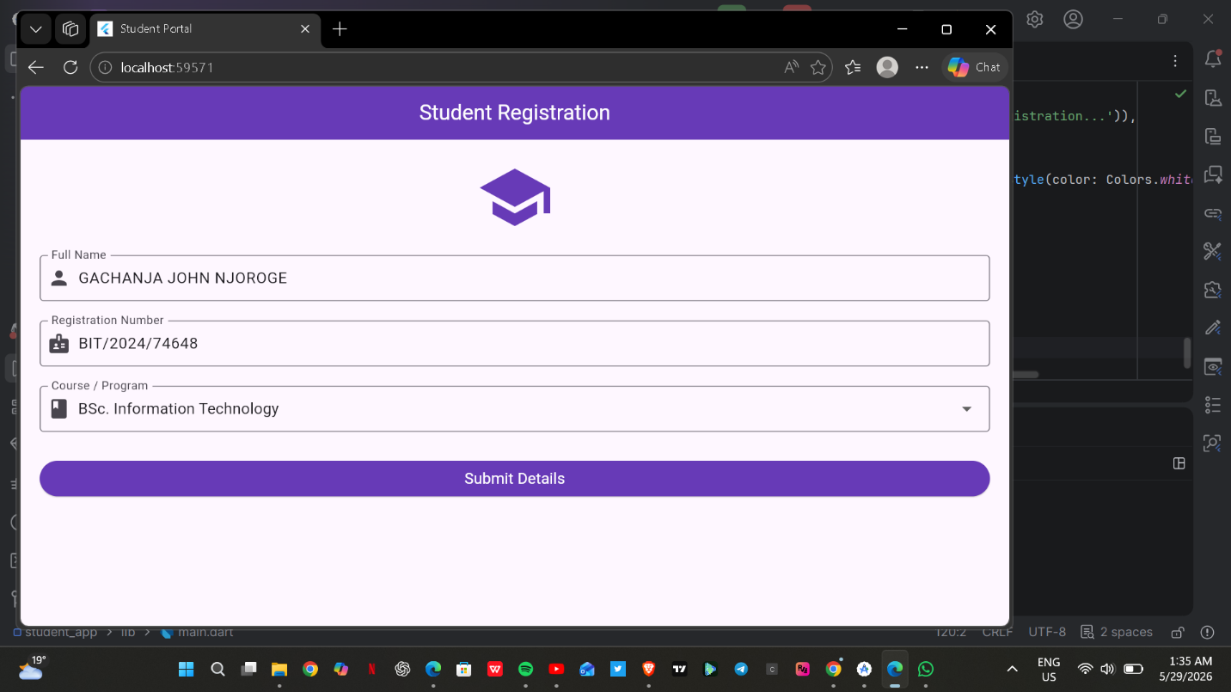
* Description: successful environment compilation and initial interface configuration running locally on local host.
WEEK 2: FORM CONTROLS & LOCAL STATE PERSISTENCE
1. OBJECTIVES:
* Implement a secure user access gateway interface (Login page).
* Create functional text input collection fields, form input validation constraints, and dropdown menus.
* Simulate a local data persistence model to hold records in runtime memory state.

2. ACTIVITIES COMPLETED:
* Implemented a Form validation system checking for empty inputs or invalid administrative entries.
* Developed an asynchronous authentication bridge accepting gateway parameters ('student' / 'mku2026').
* Formed an array-mapped simulation schema inside the Dart file layer to append active data maps during user execution.

3. EVIDENCE VERIFICATION:
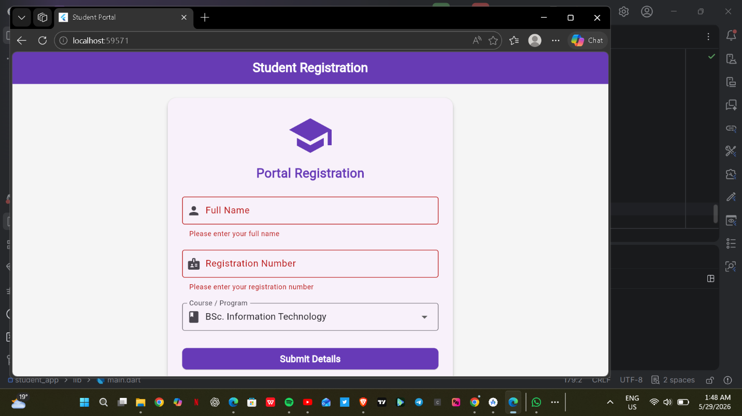
* Description: Gateway UI rejecting generic credentials and displaying context error validations.

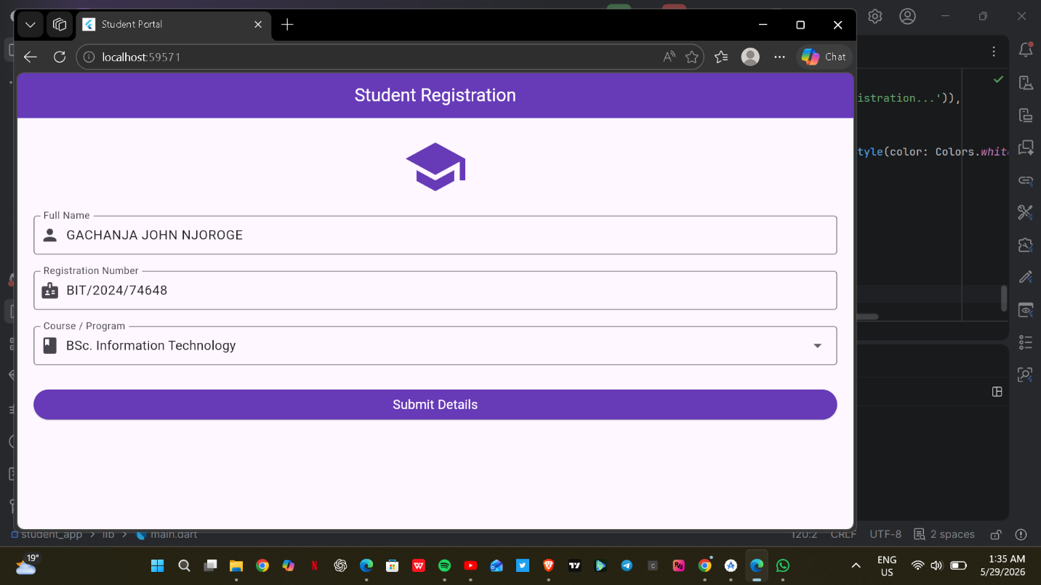
* Description: Local Student Records rendering custom data inputs mapped explicitly under Student Name: John Njoroge, Reg No: BIT/2024/74648.

WEEK 3: SCALED 5-SCREEN UI PROTOTYPE ARCHITECTURE
1. OBJECTIVES:
* Expand application topology to a minimum of 5 distinct user screens.
* Develop a clean, modern responsive Grid Layout system for operational navigation.
* Introduce a dedicated system monitoring/analytics UI node.

2. ACTIVITIES COMPLETED:
* Engineered the 'MKU Student Hub' Grid Dashboard acting as the master system node routing users dynamically across modules.
* Designed a specialized 'System Statistics' console presenting structural operational indicators, database storage load counters, and active synchronization flags.
* Finalized full cloud push synchronization updating the global repository snapshot to reflect complete multi-screen structural components.

3. EVIDENCE VERIFICATION:
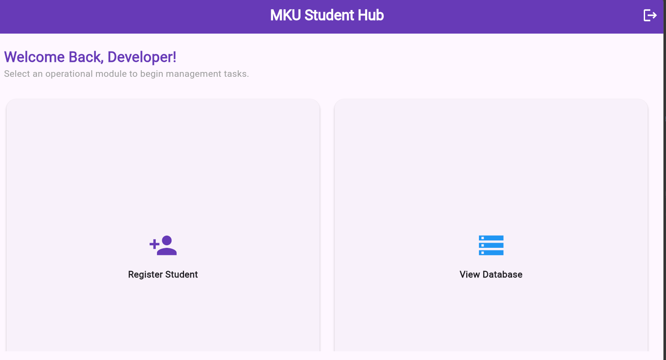
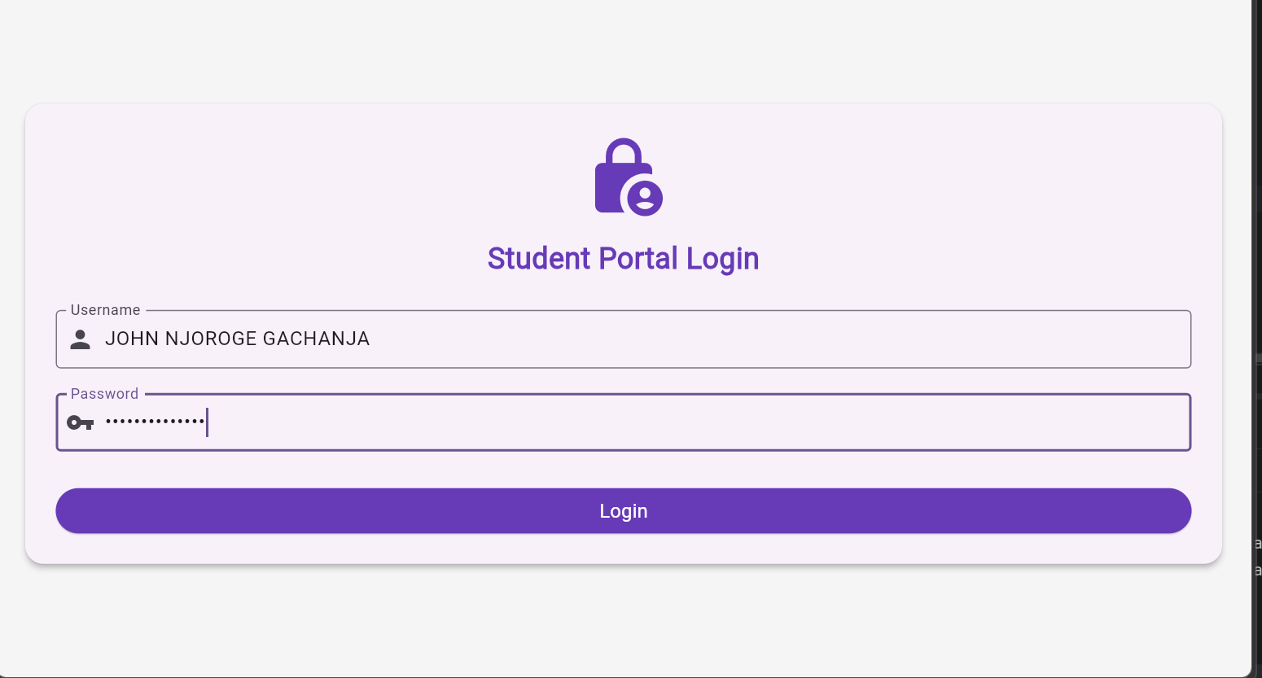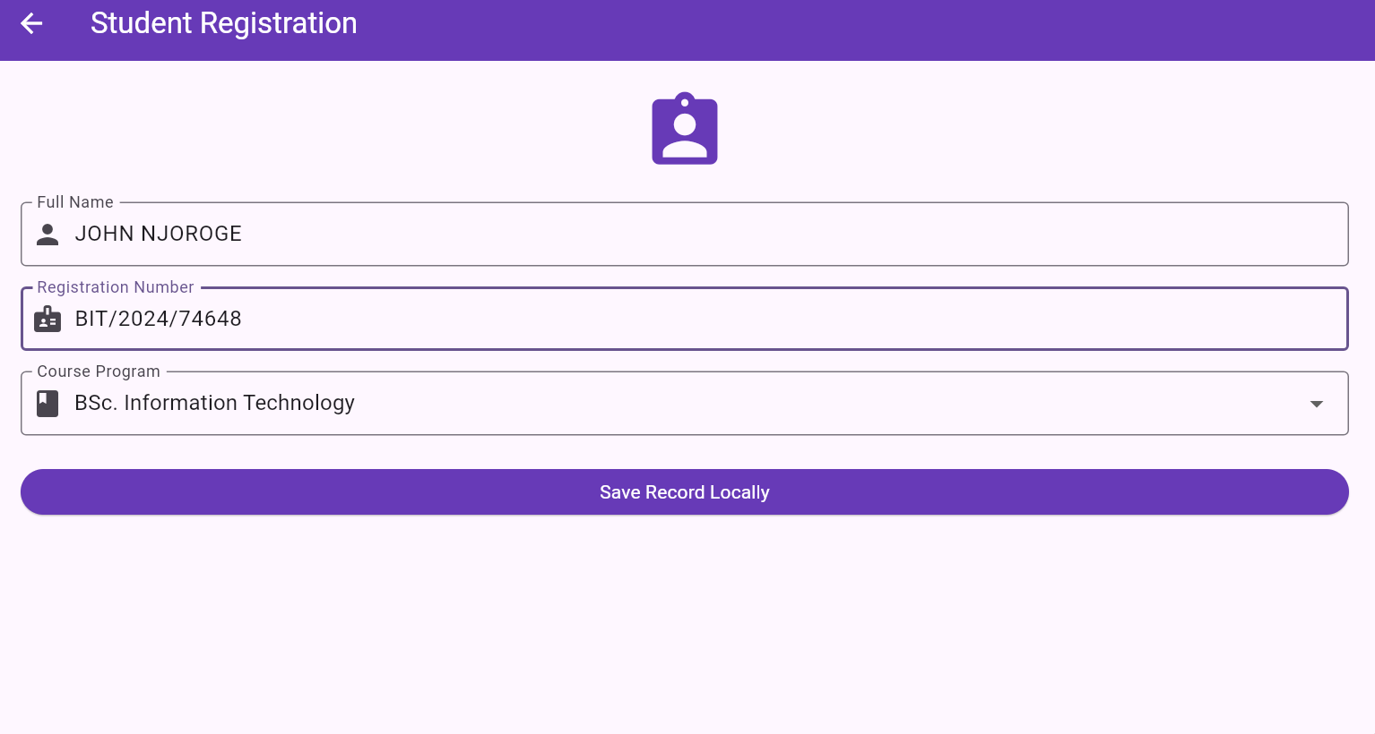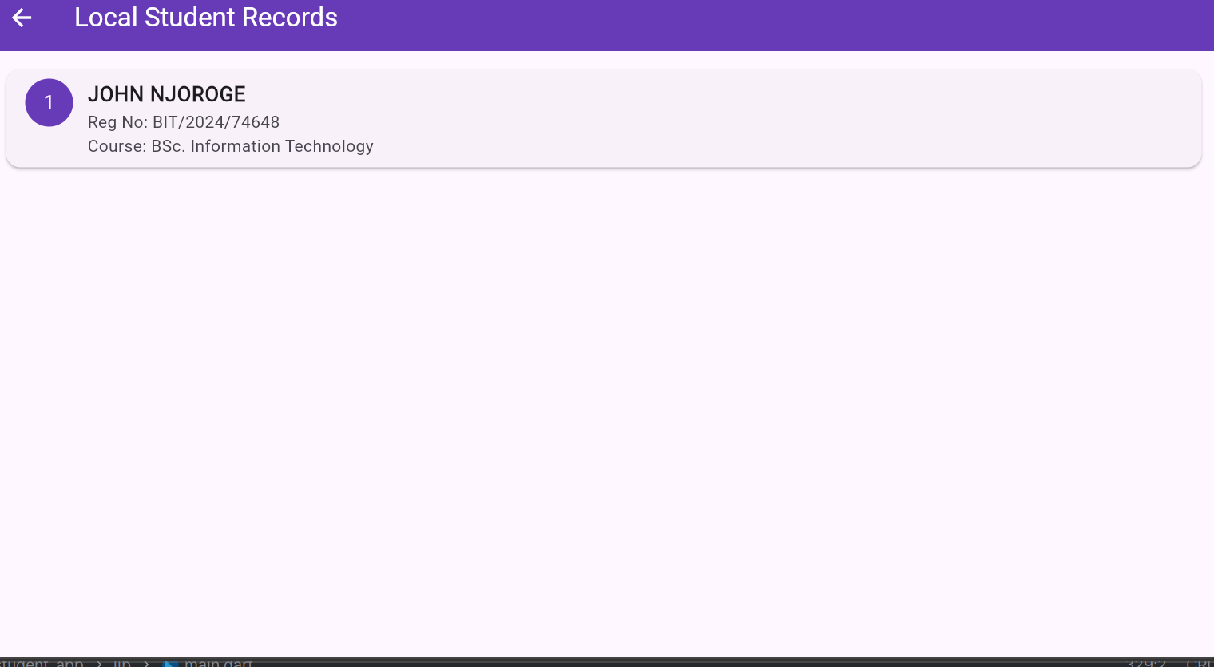* Description: Running production interface showing the operational MKU Student Hub dashboard grid modules on localhost.
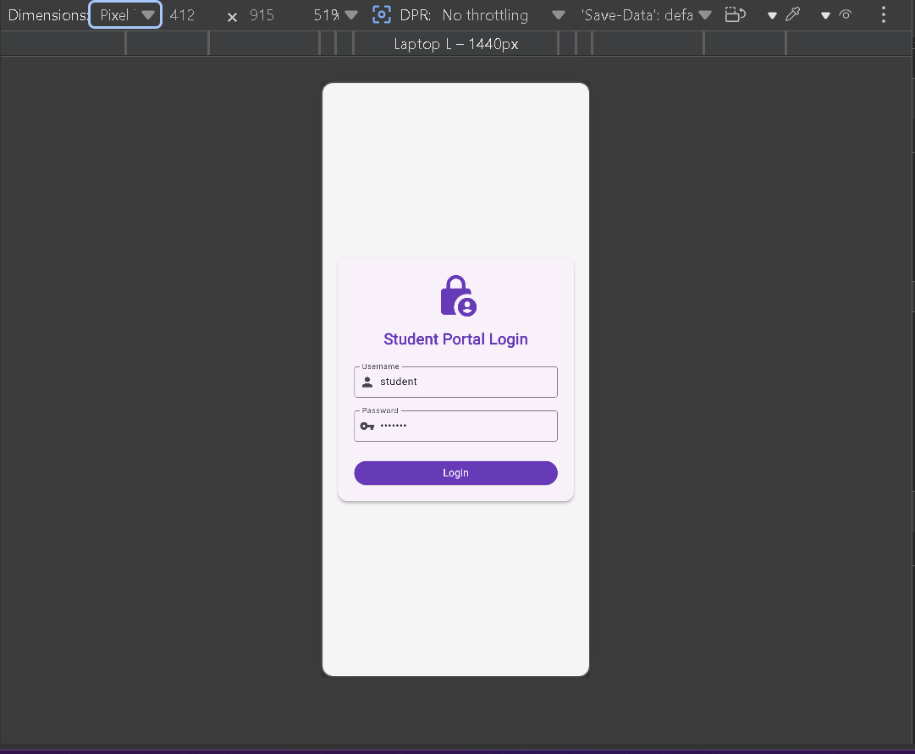
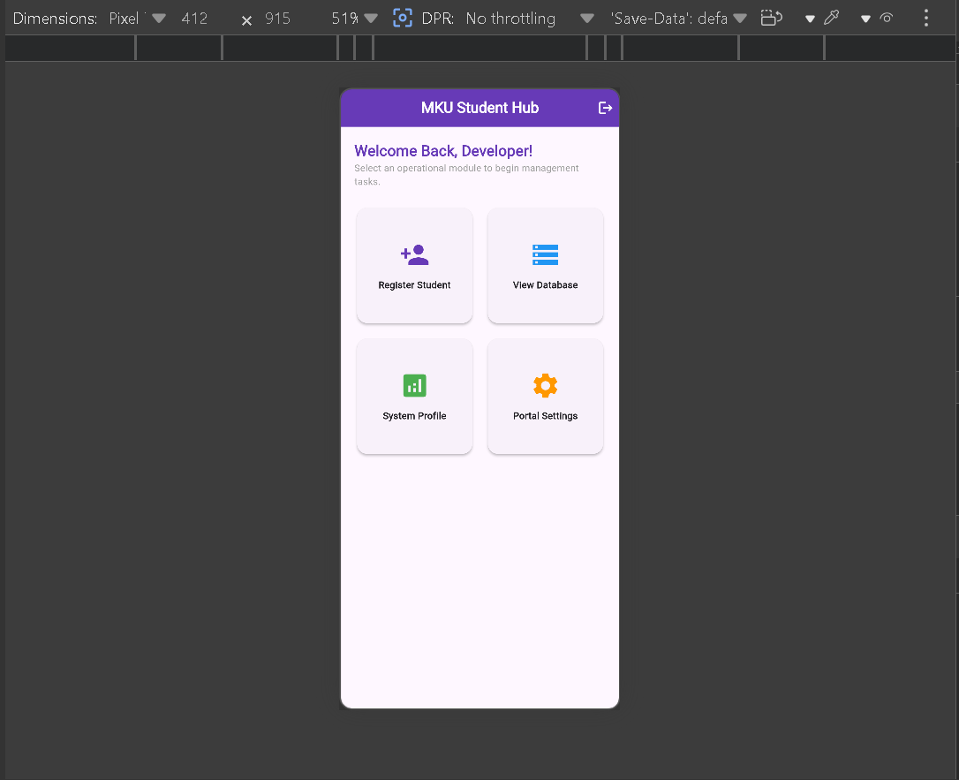
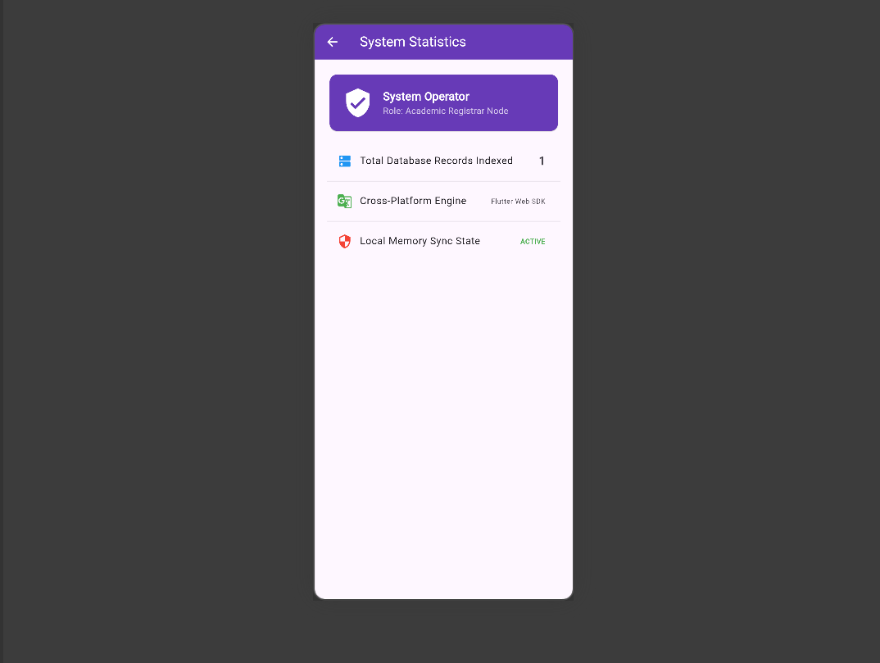
System interface verified across responsive design dimensions using mobile viewport emulators to validate layout integrity.
4. SYSTEM REFLECTION & LESSONS LEARNT:
* Successfully mastered the complete industrial cross-platform app workflow. Building decoupled widgets in Flutter proves highly efficient for fast prototyping. Setting up Git tracking weekly guarantees codebase safety and simplifies teamwork collaboration.

